**STRUCTURE OF C:**

C is a [general-purpose](https://en.wikipedia.org/wiki/General-purpose_language), [procedural](https://en.wikipedia.org/wiki/Procedural_programming) computer programming language supporting [structured programming](https://en.wikipedia.org/wiki/Structured_programming), [lexical variable scope](https://en.wikipedia.org/wiki/Lexical_variable_scope), and [recursion](https://en.wikipedia.org/wiki/Recursion_(computer_science)), while a [static type system](https://en.wikipedia.org/wiki/Static_type_system) prevents unintended operations. C was originally developed at [Bell Labs](https://en.wikipedia.org/wiki/Bell_Labs) by [Dennis Ritchie](https://en.wikipedia.org/wiki/Dennis_Ritchie) between 1972 and 1973 to make utilities running on [Unix](https://en.wikipedia.org/wiki/Unix). Later, it was applied to re-implementing the kernel of the Unix operating system. C is an [imperative](https://en.wikipedia.org/wiki/Imperative_programming) [procedural](https://en.wikipedia.org/wiki/Procedural_programming) language. It was designed to be compiled using a relatively straightforward [compiler](https://en.wikipedia.org/wiki/Compiler) to provide [low-level](https://en.wikipedia.org/wiki/Low-level_programming_language) access to [memory](https://en.wikipedia.org/wiki/Computer_memory) and language constructs that map efficiently to [machine instructions](https://en.wikipedia.org/wiki/Machine_code), all with minimal [runtime support](https://en.wikipedia.org/wiki/Runtime_system). Despite its low-level capabilities, the language was designed to encourage [cross-platform](https://en.wikipedia.org/wiki/Cross-platform_software) programming.

**STRUCTURE OF C PROGRAMMING**

**1.**Document section

**2.**Link section

**3.**Defination section

**4.**Global variable declaration

**5.**Main() function

**{**

1. declaration part
2. execution part

**}**

**Algorithm**

Step by step description of method to solve problem is called algorithm

**Flow Chart**

* The graphical representation of an algorithm using standard symbol is called flowchart
* Flow chart can be prepared before program coding

**Input variable**

**Mathematical instruction**

**SOME EXAMPLES**:

Q.1)Write c program to take inpute roll number and mark obtained by

student in subject each have it's 100 full marks and display the roll with

percentage score

**Algorithm:**

Step1: start

Step2: input 7 integer roll,sub1,sub2,sub3,sub4,sub5,sum

Step3: (sub1+sub2+sub3+sub4+sub5)/5

Step4: display the roll number and percentage

Step5: stop

**Program:**

/*c program to take inpute roll number and mark obtained by

student in subject each have it's 100 full marks and display the

roll with percentage score*/

#include <stdio.h>

int main()

{

int roll,sub1,sub2,sub3,sub4,sub5,sum;

float per;

printf("enter your roll number=");

scanf("%d",&roll);

printf("enter marks of english=");

scanf("%d",&sub1);

printf("enter marks of math=");

scanf("%d",&sub2);

printf("enter marks of physic=");

**flow chart:**

**input 7 integer roll,sub1,sub2,sub3,sub4,sub5,sum**

**(sub1+sub2+sub3+sub4+sub5)/5**

**Display the roll number and percentage**

scanf("%d",&sub3);

printf("enter marks of chemistry=");

scanf("%d",&sub4);

printf("enter marks of biology=");

scanf("%d",&sub5);

sum=(sub1+sub2+sub3+sub4+sub5)/5;

printf("the roll number of the student is %d\n",roll);

printf("percentage=%d",sum);

return 0;

}

**Output :**

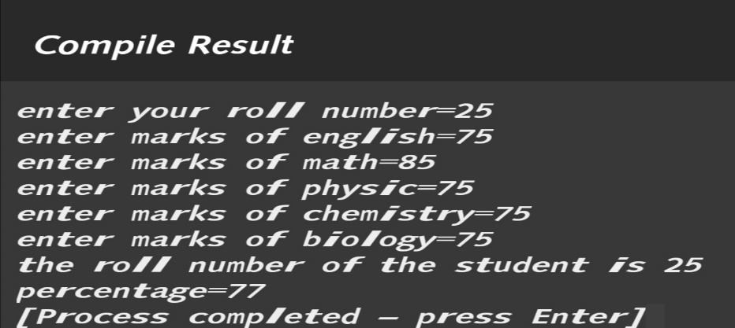

Q.2)write a c program to declor two integer one float and one character variable,

then initialize them to 15,10,12.6 and 'A',also print variable value in screen.

**Algorithm:**

Step1: start

Step2: input 2 integer as a and b

Step3: a=15, b=10, c=12.6, d='A';

Step4: display the result

Step5: stop

**Program:**

/*c program to declor two integer one float and one character variable,

then initialize them to 15,10,12.6 and 'A',also print variable value in screen*/

#include <stdio.h>

int main()

{

int a,b;

float c;

char d;

a=15;

b=10;

c=12.6;

d='A';

printf("a=%d\nb=%d\nc=%0.1f\nd=%c",a,b,c,d);

return 0;

}

**flow chart:**

**input 2 integer as a and b**

**a=15, b=10, c=12.6, d='A';**

**Display the result**

**Output:**

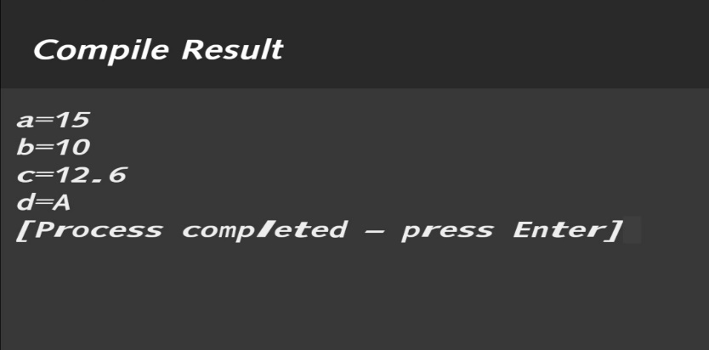

Q.3) c program to input three integer value and print these values in forward and reverse order.

**Algorithm:**

Step1: start

Step2: input 5 integer as a,b,c,forw,rev

Step3: forw=(a*100)+(b*10)+c,

rev=(c*100)+(b*10)+a

Step4: display the forward and reverse result

Step5: stop

**Program:**

/* c program to input three integer value and print these values in forward and reverse order*/

#include <stdio.h>

int main()

{

int a,b,c,forw,rev;

printf("enter 1st integer=");

scanf("%d",&a);

printf("enter 2nd integer=");

scanf ("%d",&b);

printf("enter 3rd integer=");

scanf("%d",&c);

forw=(a*100)+(b*10)+c;

rev=(c*100)+(b*10)+a;

printf("forward=%d\nreverse=%d\n",forw,rev);

return 0;

}

**Output:**

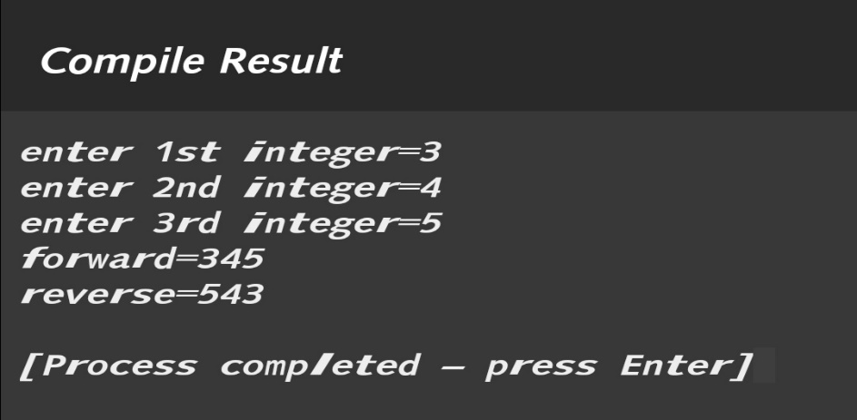

**flow chart:**

**input 5 integer as a,b,c,forw,rev**

**forw=(a*100)+(b*10)+c,**

**rev=(c*100)+(b*10)+a**

**display the forward and reverse result**

Q.4)

i) write a c program to swap two variable value without use of third variable.

**Algorithm:**

Step1: start

Step2: input 2 integer as a,b

Step3: a=a+b

b=a-b

a=a-b

Step4: display the swap result

Step5: stop

**Program:**

/*c program to swap two variable value without use of third variable*/

#include <stdio.h>

int main()

{

int a,b;

printf("enter A=");

scanf("%d",&a);

printf("enter B=");

scanf("%d",&b);

a=a+b;

b=a-b;

a=a-b;

printf("A=%d\n",a);

printf("B=%d",b);

return 0;

}

**flow chart:**

**input 2 integer as a,b**

**a=a+b ,b=a-b, a=a-b**

**display the swap result**

**Output:**

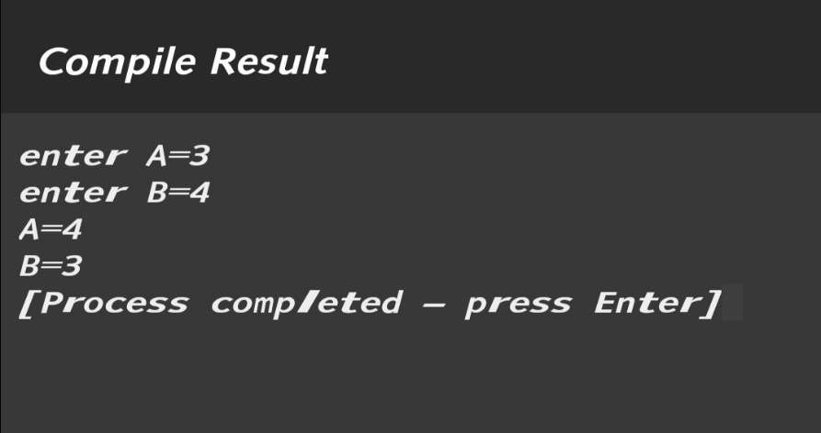

ii)write a c program to swap two variable value with use of third variable.

**Algorithm:**

Step1: start

Step2: input 3 integer a,b,c

Step3: c=a, a=b, b=c

Step4: display the swap result

Step5: stop

**Program:**

/*c program to swap two variable value with use of third variable*/

#include <stdio.h>

int main()

{

int a,b,c;

printf("enter A=");

scanf("%d",&a);

printf("enter B=");

scanf("%d",&b);

**flow chart:**

**input 3 integer as a,b,c**

**c=a, a=b, b=c**

**display the swap result**

c=a;

a=b;

b=c;

printf("A=%d\n",a);

printf("B=%d",b);

return 0;

}

**Output:**

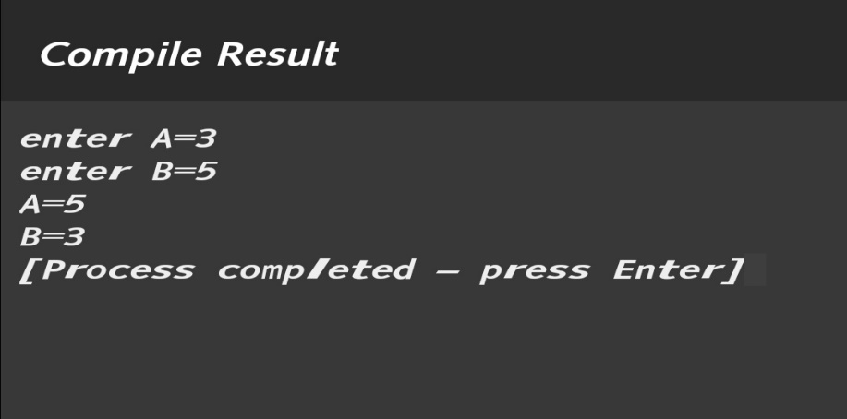

Q.5) c program to use enum and type def keyword for user defined data type.

**Algorithm:**

Step1: start

Step2: input

Step3:

Step4: display the

Step5: stop

**Program:**

/*c program to use enum and type def keyword for user defined data type*/

#include <stdio.h>

int main()

{

**flow chart:**

**input**

**display the**

enum day{sun,mon,tue,wed,thru,fri,sat};

int day=wed;

printf("%d\n",day);

typedef int integer;

integer a=10;

printf("%d",a);

return 0;

}

**Output**

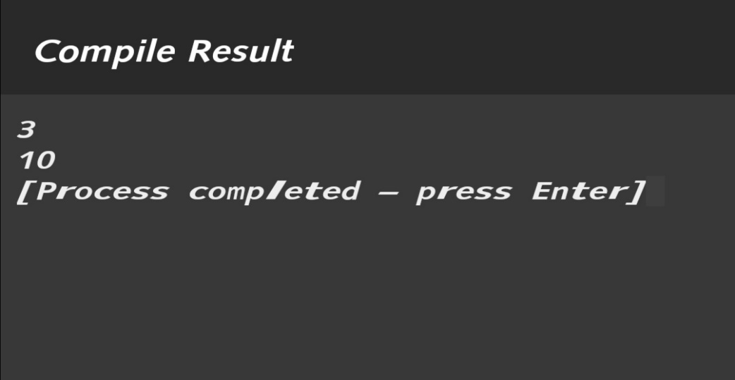

Q.6)write c program to convert days into month and days.

**Algorithm:**

Step1: start

Step2: input 3 integer inputdays,month,days

Step3: month=inputdays/30

days=inputdays%30

Step4: display the month and days result

Step5: stop

**flow chart:**

**input 3 integer inputdays,month,days**

**month=inputdays/30**

**days=inputdays%30**

**display the month and days result**

**Program:**

/*c program to convert days into month and days*/

#include <stdio.h>

int main()

{

int inputdays,month,days;

printf("input enter number of days=");

scanf("%d",&inputdays);

month=inputdays/30;

days=inputdays%30;

printf("the no. of month=%d\n",month);

printf("the no. of days=%d",days);

return 0;

}

**Output:**

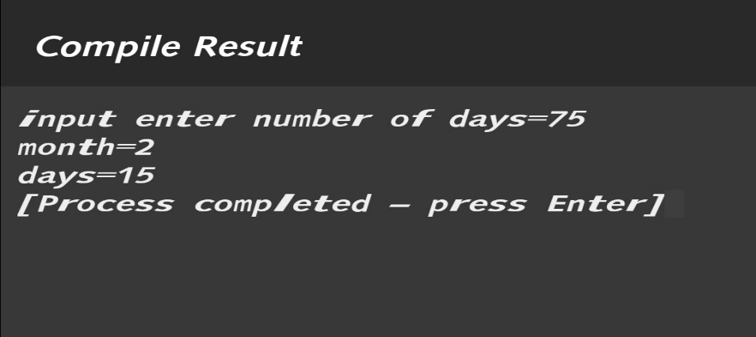

**Conclusion:**

**Input variable**

**Mathematical instruction**

**flow chart:**

**input 7 integer roll,sub1,sub2,sub3,sub4,sub5,sum**

**(sub1+sub2+sub3+sub4+sub5)/5**

**Display the roll number and percentage**

**flow chart:**

**input 2 integer as a and b**

**a=15, b=10, c=12.6, d='A';**

**Display the result**

**flow chart:**

**input 5 integer as a,b,c,forw,rev**

**forw=(a*100)+(b*10)+c,**

**rev=(c*100)+(b*10)+a**

**display the forward and reverse result**

**flow chart:**

**input 2 integer as a,b**

**a=a+b ,b=a-b, a=a-b**

**display the swap result**

**flow chart:**

**input 3 integer as a,b,c**

**c=a, a=b, b=c**

**display the swap result**

**flow chart:**

**input**

**display the**

**flow chart:**

**input 3 integer inputdays,month,days**

**month=inputdays/30**

**days=inputdays%30**

**display the month and days result**